1. Download freeTTS libraries and include them in my Java project in eclipse.

Use this link: <http://sourceforge.net/projects/freetts/files/FreeTTS/FreeTTS%201.2.2/freetts-1.2.2-bin.zip/download>

1. When you unzip go to libraries folder and add all jars into build path of project.
2. Download mbr301d.zip, extract it in a folder named mbrola within my project

Use this link: <http://tcts.fpms.ac.be/synthesis/mbrola/bin/pcdos/mbr301d.zip>

1. Download mbrola database for us1, us2, us3 and en1 from <http://www.tcts.fpms.ac.be/synthesis/mbrola/mbrcopybin.html>
2. goto 2) Getting the MBROLA Voices section and select the language you want
3. extract the voice DB zips downloaded in previous step directly in mbrola folder - don't change names of the folders.
4. include following code pieces to use it:

System.setProperty("mbrola.base","ABSOLUTE_PATH_TO_mbrola_directory_ending_with_/");

voiceManager = VoiceManager.getInstance();

voice = voiceManager.getVoice("mbrola_us1");

folder structure

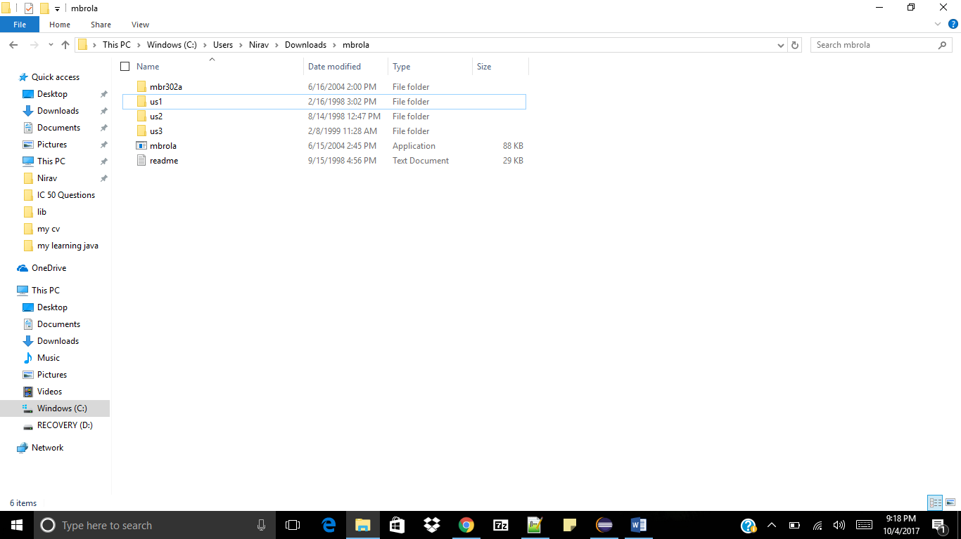

Note: folder name is us1 but voice name is mbrola_us1.So don’t get confused

You can use following code to see available voices

System.*setProperty*("mbrola.base", "C:/Users/Nirav/Downloads/mbrola/");

**for**(Voice v:VoiceManager.*getInstance*().getVoices())

{

System.***out***.println(v.getName()+"\n");

}

More info: https://stackoverflow.com/questions/26236562/mbrola-voices-with-freetts-windows